On January 1, 2021, Canseco Plumbing Fixtures purchased equipment for $66,000. Residual value at the end of an estimated four-year service life is expected to be $6,000. The company expects the equipment to operate for 15,000 hours. The equipment operated for 4,000 and 4,800 hours in 2021 and 2022, respectively.

**Required:**  
  
**a.** Calculate depreciation expense for 2021 and 2022 using straight line method.

**b.** Calculate depreciation expense for 2021 and 2022 using double-declining balance method.  
**c.** Calculate depreciation expense for 2021 and 2022 using units-of-production using hours operated.  
  
a. 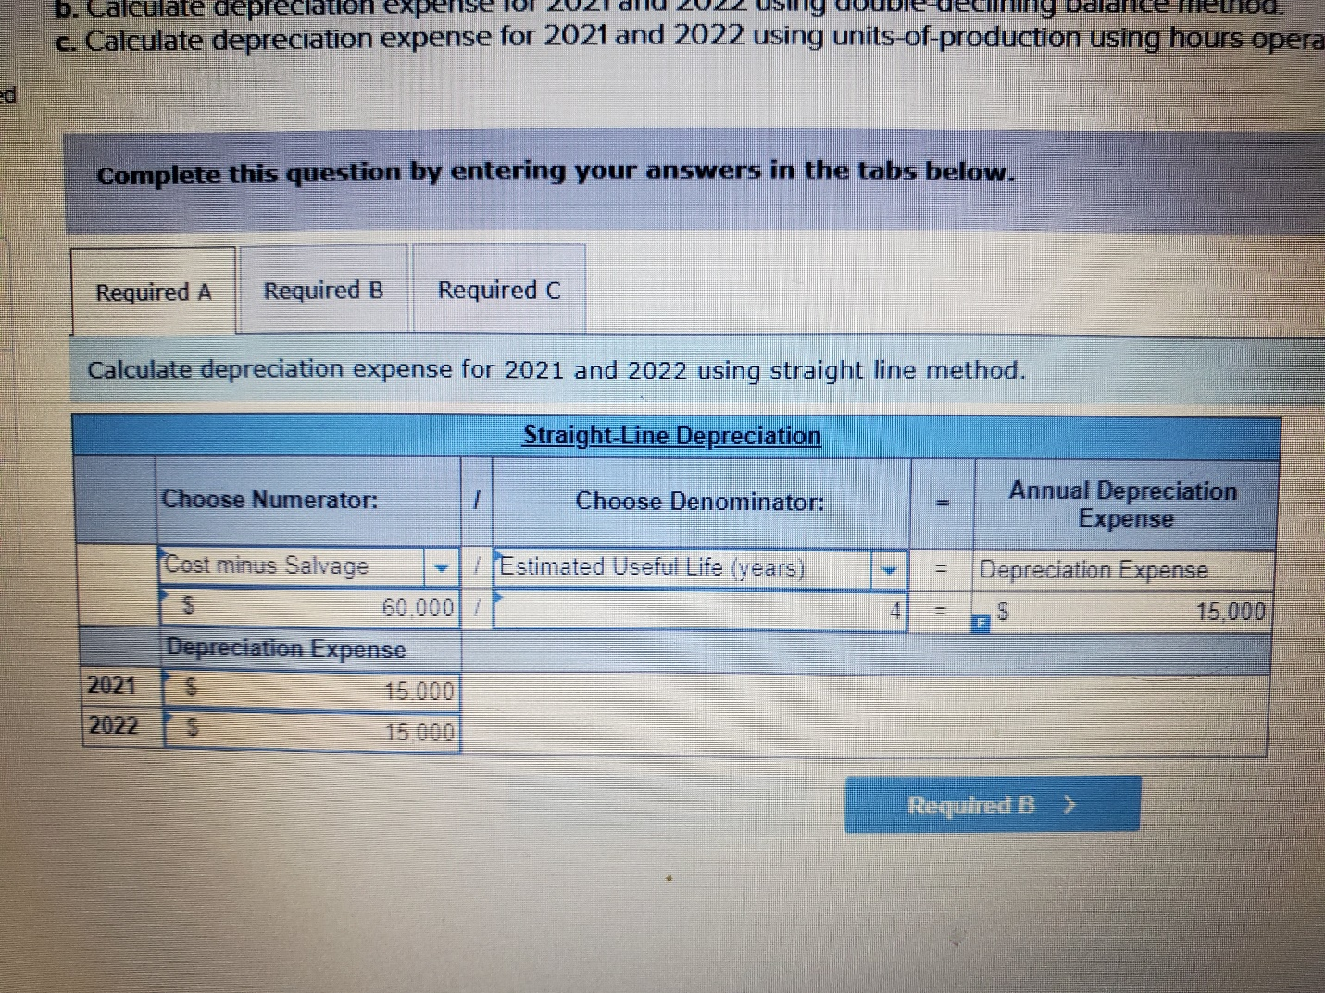

b. 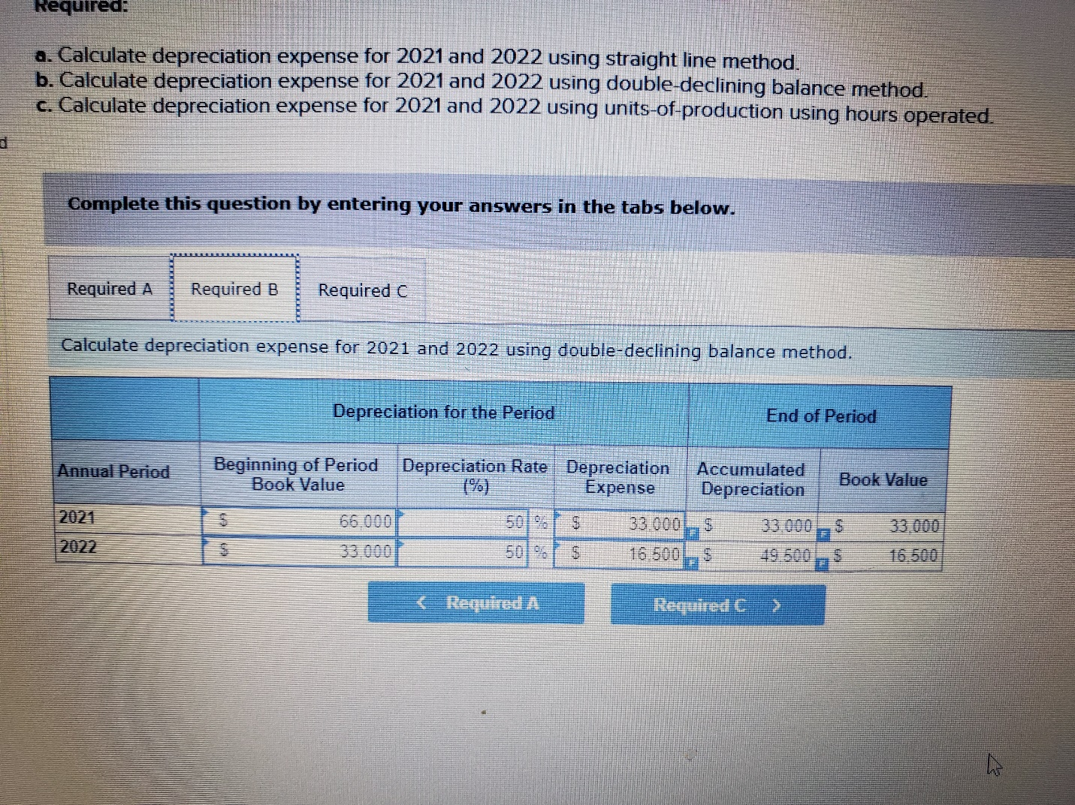

**c.** 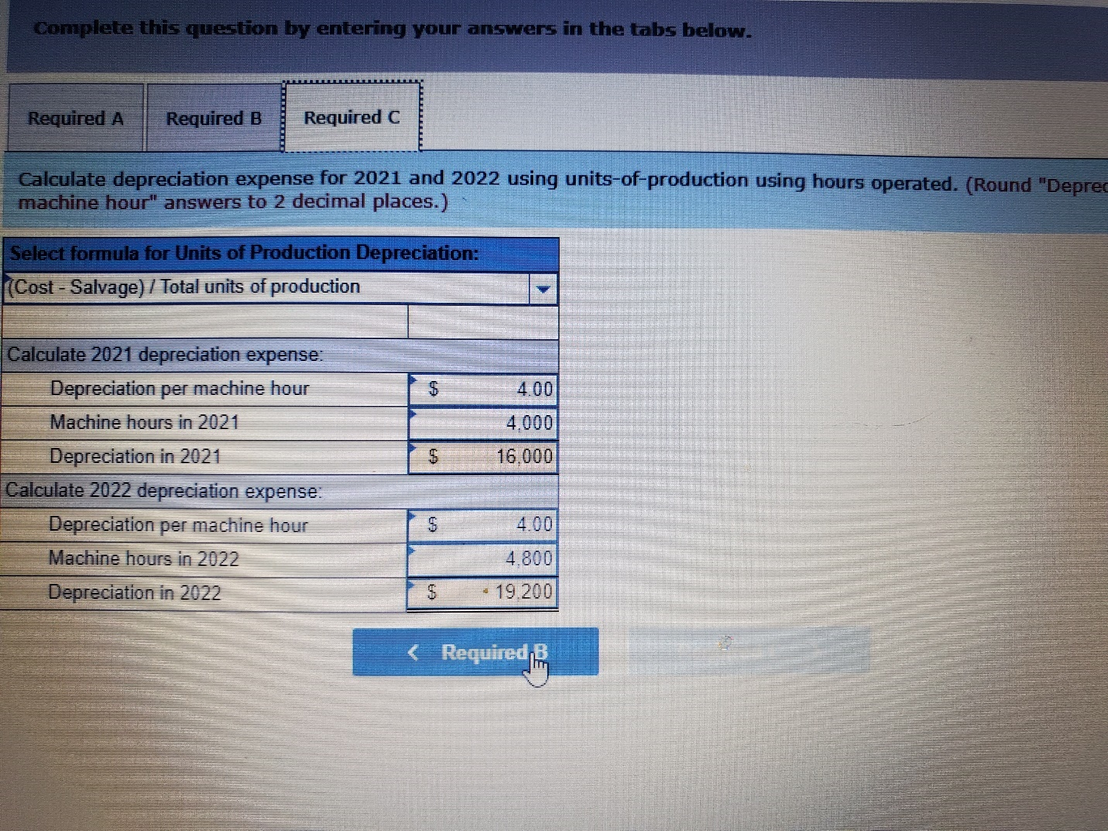

**Explanation**

**a.**  
Straight-line:

|  |  |  |  |  |
| --- | --- | --- | --- | --- |
| $66,000 – 6,000 | = | $ | 15,000 | per year |
| 4 years |

**b.**  
Double-declining balance:  
   
Straight-line rate is 25% (1 ÷ 4 years) × 2 =  50% DDB rate

|  |  |  |  |  |
| --- | --- | --- | --- | --- |
| 2021 | $66,000 × 50% | = | $ | 33,000 |
| 2022 | ($66,000 – 33,000) × 50% | = | $ | 16,500 |

**c.**  
Units-of-production:

|  |  |  |  |  |
| --- | --- | --- | --- | --- |
| $66,000 – 6,000 | = | $ | 4.00 | per unit depreciation rate |
| 15,000 hours |

|  |  |  |  |  |
| --- | --- | --- | --- | --- |
| 2021 | 4,000 hours × $4.00 | = | $ | 16,000 |
| 2022 | 4,800 hours × $4.00 | = | $ | 19,200 |
|  |  |  |  |  |

2. At the beginning of 2019, Robotics Inc. acquired a manufacturing facility for $12.9 million. $9.9 million of the purchase price was allocated to the building. Depreciation for 2019 and 2020 was calculated using the straight-line method, a 25-year useful life, and a $1.9 million residual value. In 2021, the estimates of useful life and residual value were changed to 20 total years and $590,000, respectively.  
   
What is depreciation on the building for 2021? **(Round answer to the nearest whole dollar.)**

  

**Explanation**

Calculation of annual depreciation after the estimate change:

|  |  |  |  |  |  |
| --- | --- | --- | --- | --- | --- |
|  |  |  |  |  |  |
|  |  |  | $ | 9,900,000 | Cost |
|  | $320,000 |  |  |  | Previous annual depreciation ($8 million ÷ 25 years) |
|  | × 2 years |  |  | (640,000) | Less: Depreciation to date (2019-2020) |
|  |  |  |  | 9,260,000 | Undepreciated cost |
|  |  |  |  | (590,000) | Less: Revised residual value |
|  |  |  |  | 8,670,000 | Revised depreciable base |
|  |  |  | ÷ | 18 | Estimated remaining life − 18 years (20 − 2) |
|  |  |  | $ | 481,667 | 2021 depreciation |
|  | | | | | |

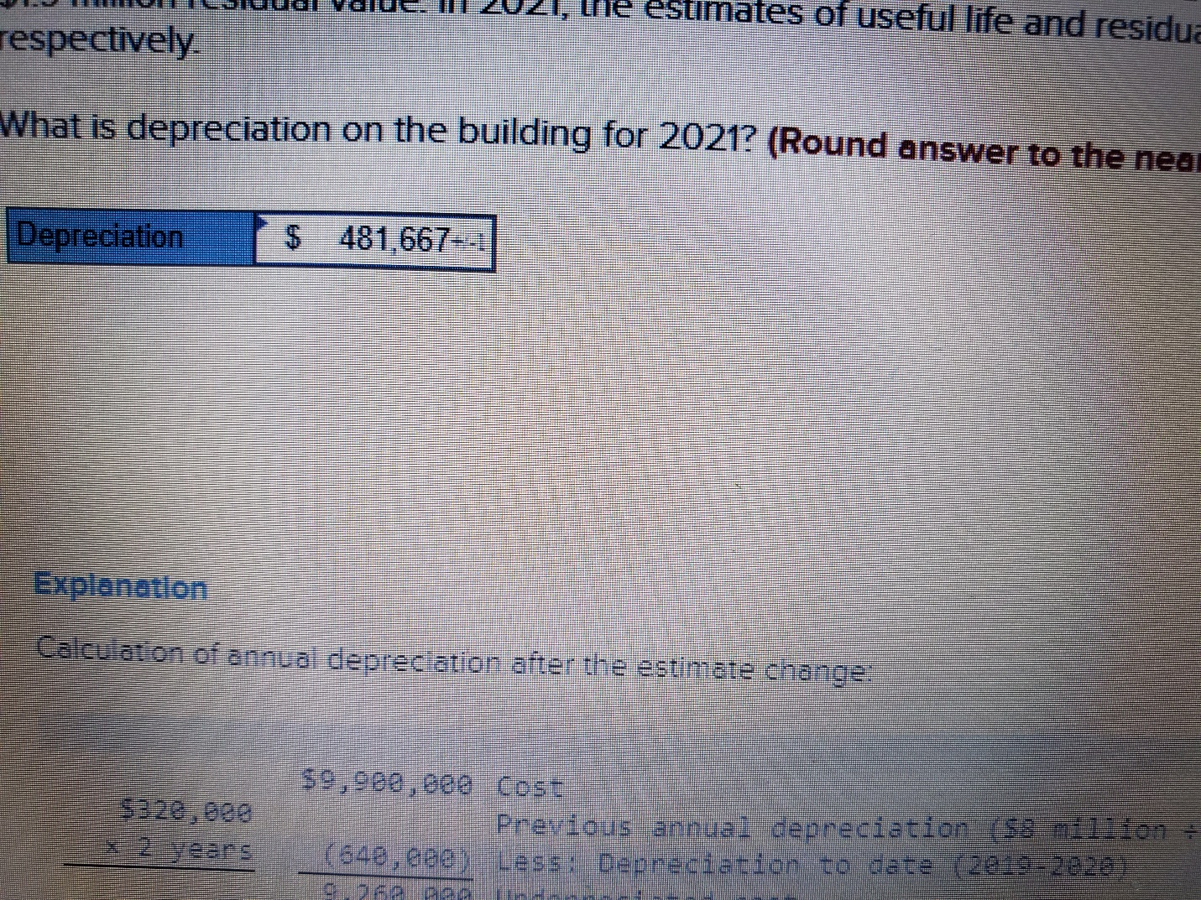

3. Collison and Ryder Company (C&R) has been experiencing declining market conditions for its sportswear division. Management decided to test the assets of the division for possible impairment. The test revealed the following: book value of division’s assets, $30.1 million; fair value of division’s assets, $22.8 million; undiscounted sum of estimated future cash flows generated from the division’s assets, $30.5 million.  
  
What amount of impairment loss should C&R recognize? **(Enter your answer in whole dollars.)**  
  

## Explanation

Recoverability test: Because the undiscounted sum of future cash flows of $30.5 million exceeds book value of $30.1 million, there is no impairment loss to measure. 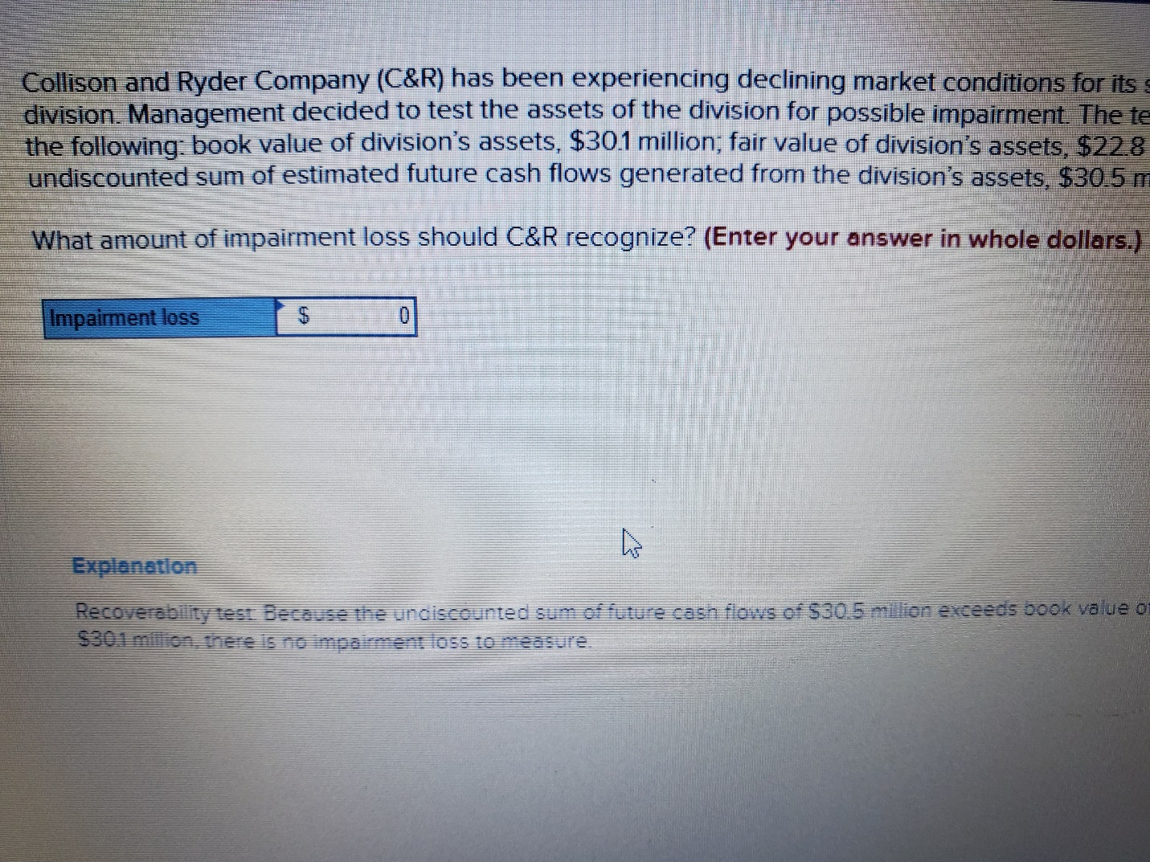

4. On March 31, 2021, Susquehanna Insurance purchased an office building for $14,400,000. Based on their relative fair values, one-third of the purchase price was allocated to the land and two-thirds to the building. Furniture and fixtures were purchased separately from office equipment on the same date for $1,280,000 and $780,000, respectively. The company uses the straight-line method to depreciate its buildings and the double-declining-balance method to depreciate all other depreciable assets. The estimated useful lives and residual values of these assets are as follows:

|  |  |  |
| --- | --- | --- |
|  | Service Life | Residual Value |
| Building | 40 | 10% of cost |
| Furniture and fixtures | 20 | 10% of cost |
| Office equipment | 10 | $38,000 |
|  | | |

**Required:**  
Calculate depreciation for 2021 and 2022. **(Do not round intermediate calculations.)**  
 

**Explanation**

Building depreciation:

|  |  |
| --- | --- |
| $9,600,000* − $960,000** | = $216,000 per year |
| 40 years |

*$14,400,000 total × 2/3 for building cost  
**$9,600,000 × 10%  
   
2021: $216,000 × 9/12 = $162,000  
2022: $216,000  
   
Furniture and fixtures depreciation:

|  |  |  |  |  |
| --- | --- | --- | --- | --- |
|  |  |  |  |  |
| 1/20 or 5% (the straight-line rate) × 2 | = | 10% DDB rate | | |
| 2021: $1,280,000 × 10% × 9/12 | = | $ | 96,000 |  |
| 2022: ($1,280,000 − $96,000) × 10% | = | $ | 118,400 |  |
|  | | | | |

Office equipment depreciation:

|  |  |  |  |  |
| --- | --- | --- | --- | --- |
|  |  |  |  |  |
| 1/10 or 10% (the straight-line rate) × 2 | = | 20% DDB rate | | |
| 2021: $780,000 × 20% × 9/12 | = | $ | 117,000 |  |
| 2022: ($780,000 − $117,000) × 20% | = | $ | 132,600 |  |
|  | | | | |

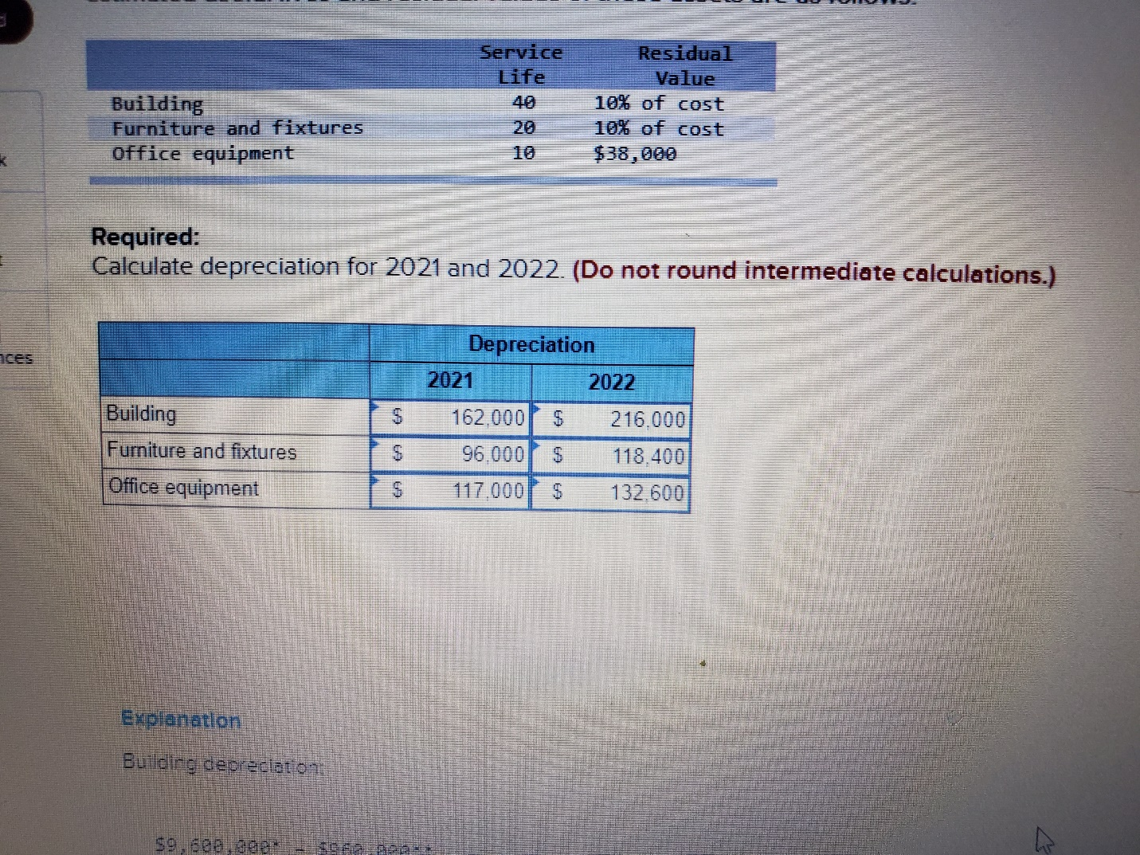

5.On January 2, 2021, the Jackson Company purchased equipment to be used in its manufacturing process. The equipment has an estimated life of eight years and an estimated residual value of $56,625. The expenditures made to acquire the asset were as follows:

|  |  |  |  |
| --- | --- | --- | --- |
|  |  |  |  |
| Purchase price | $ | 242,000 |  |
| Freight charges |  | 8,400 |  |
| Installation charges |  | 12,000 |  |
|  | | | |

Jackson’s policy is to use the double-declining-balance (DDB) method of depreciation in the early years of the equipment’s life and then switch to straight line halfway through the equipment’s life.  
   
**Required:**

**1.** Calculate depreciation for each year of the asset’s eight-year life.  
**2.** Are changes in depreciation methods accounted for retrospectively or prospectively?  
 

**Explanation**

**1.**  
Capitalized cost of the equipment:

|  |  |  |  |
| --- | --- | --- | --- |
|  |  |  |  |
| Purchase price | $ | 242,000 |  |
| Freight charges |  | 8,400 |  |
| Installation charges |  | 12,000 |  |
| Capitalized cost | $ | 262,400 |  |
|  | | | |

Straight-line rate of 12.5% (1 ÷ 8 years) × 2 = 25% DDB rate.

|  |  |  |  |  |  |  |  |  |  |  |  |  |  |  |
| --- | --- | --- | --- | --- | --- | --- | --- | --- | --- | --- | --- | --- | --- | --- |
| Year | Book Value Beginning of Year | | | × | Depreciation Rate per Year | | = | Depreciation | | | | Book Value End of Year | | |
| 2021 | $ | 262,400 |  |  | 25 | % |  |  | $ | 65,600 |  | $ | 196,800 |  |
| 2022 |  | 196,800 |  |  | 25 | % |  |  |  | 49,200 |  |  | 147,600 |  |
| 2023 |  | 147,600 |  |  | 25 | % |  |  |  | 36,900 |  |  | 110,700 |  |
| 2024 |  | 110,700 |  |  | 25 | % |  |  |  | 27,675 |  |  | 83,025 |  |
| 2025 |  | 83,025 |  |  | * |  |  |  |  | 6,600 |  |  | 76,425 |  |
| 2026 |  | 76,425 |  |  | * |  |  |  |  | 6,600 |  |  | 69,825 |  |
| 2027 |  | 69,825 |  |  | * |  |  |  |  | 6,600 |  |  | 63,225 |  |
| 2028 |  | 63,225 |  |  | * |  |  |  |  | 6,600 |  |  | 56,625 |  |
| Total |  |  |  |  |  |  |  |  | $ | 205,775 |  |  |  |  |
|  | | | | | | | | | | | | | | |

* Switch to straight-line in 2025:  
   
$(83,025 − $56,625) / 4 years = $6,600/ year  
  
**2.**  
Generally accepted accounting principles allow a company to change from one depreciation method to another if the company can justify the change. For example, new information might become available to suggest that a different depreciation method would better represent the pattern of the asset’s consumption relative to revenue production. We account for these changes prospectively.

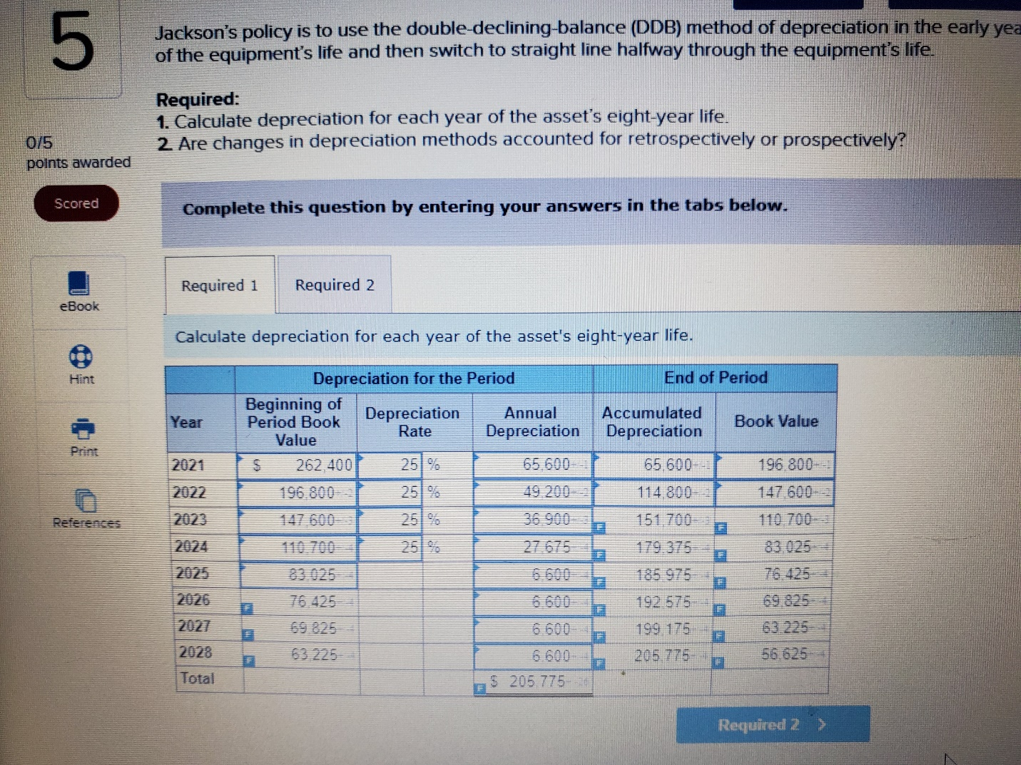

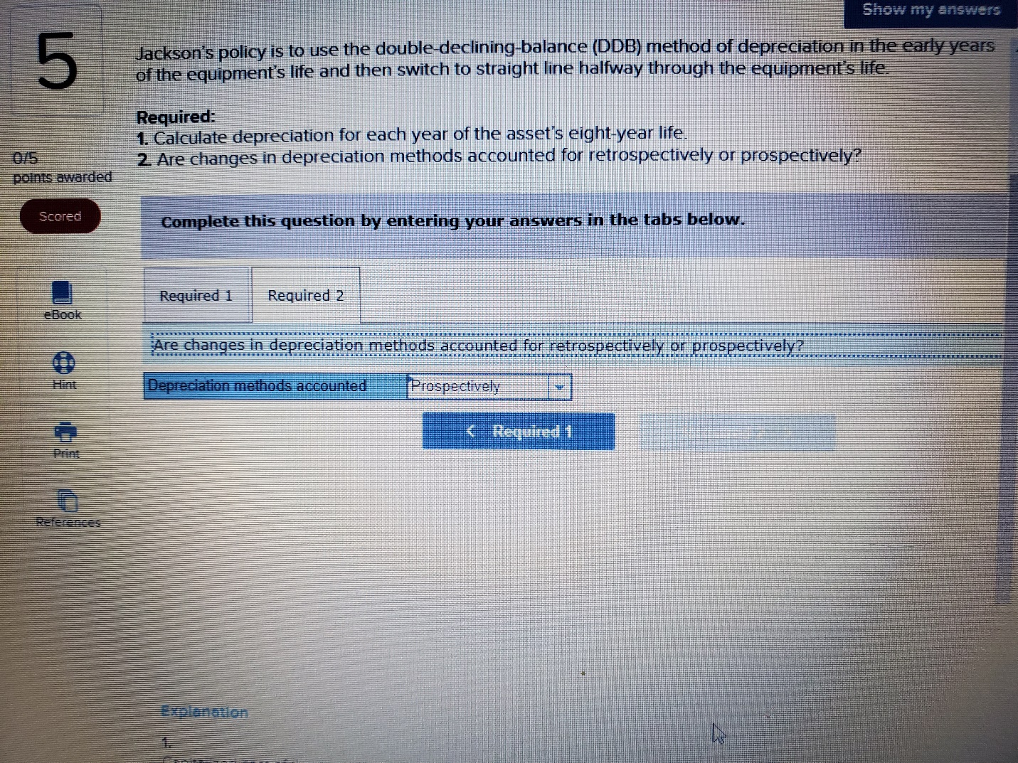

6. Jackpot Mining Company operates a copper mine in central Montana. The company paid $1,650,000 in 2021 for the mining site and spent an additional $730,000 to prepare the mine for extraction of the copper. After the copper is extracted in approximately four years, the company is required to restore the land to its original condition, including repaving of roads and replacing a greenbelt. The company has provided the following three cash flow possibilities for the restoration costs: ([FV of $1](https://ezto.mheducation.com/extMedia/bne/accounting/spiceland_int_10e/table_1.png), [PV of $1](https://ezto.mheducation.com/extMedia/bne/accounting/spiceland_int_10e/table_2.png), [FVA of $1](https://ezto.mheducation.com/extMedia/bne/accounting/spiceland_int_10e/table_3.png), [PVA of $1](https://ezto.mheducation.com/extMedia/bne/accounting/spiceland_int_10e/table_4.png), [FVAD of $1](https://ezto.mheducation.com/extMedia/bne/accounting/spiceland_int_10e/table_5.png) and [PVAD of $1](https://ezto.mheducation.com/extMedia/bne/accounting/spiceland_int_10e/table_6.png)) **(Use appropriate factor(s) from the tables provided.)**

|  |  |  |  |  |
| --- | --- | --- | --- | --- |
|  | Cash Outflow | | | Probability |
| 1 | $ | 430,000 |  | 15% |
| 2 |  | 530,000 |  | 45% |
| 3 |  | 730,000 |  | 40% |
|  | | | | |

To aid extraction, Jackpot purchased some new equipment on July 1, 2021, for $260,000. After the copper is removed from this mine, the equipment will be sold for an estimated residual amount of $34,000. There will be no residual value for the copper mine. The credit-adjusted risk-free rate of interest is 10%.  
   
The company expects to extract 11.3 million pounds of copper from the mine. Actual production was 2.9 million pounds in 2021 and 4.3 million pounds in 2022.  
   
**Required:**  
**1.** Compute depletion and depreciation on the mine and mining equipment for 2021 and 2022. The units-of-production method is used to calculate depreciation. **(The expected format for rounding is presented in the appropriate rows of the table. Round your final answers to nearest whole dollar.)**

**Explanation**

**1.** Cost of copper mine:

|  |  |  |  |  |
| --- | --- | --- | --- | --- |
|  |  | | | |
| Mining site | $ | 1,650,000 |  |  |
| Development costs |  | 730,000 |  |  |
| Restoration costs |  | 406,391 | † |  |
|  | $ | 2,786,391 |  |  |
|  | | | | |

|  |  |  |  |  |  |  |  |  |  |  |  |  |  |  |  |  |
| --- | --- | --- | --- | --- | --- | --- | --- | --- | --- | --- | --- | --- | --- | --- | --- | --- |
|  | | | | | | | | | | | | | | | | |
| † | $ | 430,000 |  | × | 15% | = | $ | 64,500 |  |  |  |  |  |  |  |  |
|  |  | 530,000 |  | × | 45% | = |  | 238,500 |  |  |  |  |  |  |  |  |
|  |  | 730,000 |  | × | 40% | = |  | 292,000 |  |  |  |  |  |  |  |  |
|  |  |  |  |  |  |  | $ | 595,000 | × | 0.68301 | * | = | $ | 406,391 |  |  |
|  | | | | | | | | | | | | | | | | |

*Present value of $1, *n* = 4, *i* = 10% (PV of $1)  
   
Depletion:

|  |  |  |
| --- | --- | --- |
| Depletion per pound = | $2,786,391 | = $0.2466 per pound |
| 11,300,000 pounds |

|  |  |  |  |  |  |  |  |  |  |  |  |  |
| --- | --- | --- | --- | --- | --- | --- | --- | --- | --- | --- | --- | --- |
|  |  |  |  | | |  |  |  |  |  | | |
| 2021 | depletion | = | $ | 0.2466 |  | × | 2,900,000 | pounds | = | $ | 715,140 |  |
| 2022 | depletion | = | $ | 0.2466 |  | × | 4,300,000 | pounds | = | $ | 1,060,380 |  |
|  | | | | | | | | | | | | |

Depreciation:

|  |  |  |
| --- | --- | --- |
| Depreciation per pound = | $260,000 − $34,000 | = $0.02 per pound |
| 11,300,000 pounds |

|  |  |  |  |  |  |  |  |  |  |  |  |  |
| --- | --- | --- | --- | --- | --- | --- | --- | --- | --- | --- | --- | --- |
|  |  |  |  | | |  |  |  |  |  | | |
| 2021 | depreciation | = | $ | 0.02 |  | × | 2,900,000 | pounds | = | $ | 58,000 |  |
| 2022 | depreciation | = | $ | 0.02 |  | × | 4,300,000 | pounds | = | $ | 86,000 |  |
|  | | | | | | | | | | | | |

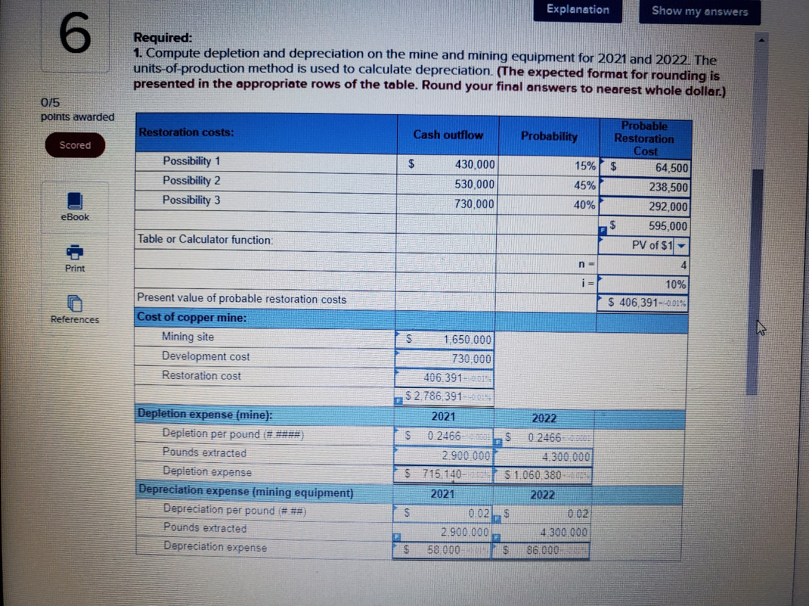

7. In 2021, internal auditors discovered that PKE Displays, Inc. had debited an expense account for the $356,000 cost of equipment purchased on January 1, 2018. The equipment’s life was expected to be five years with no residual value. Straight-line depreciation is used by PKE.  
   
**Required:**  
**1.**Determine the cumulative effect of the error on net income over the three-year period from 2018 through 2020, and on retained earnings by the end of 2020.  
**2.** Prepare the correcting entry assuming the error was discovered in 2021 before the adjusting and closing entries. (Ignore income taxes.)  
**3.** Assume instead that the equipment was disposed of in 2022 and the original error was discovered in 2023 after the 2022 financial statements were issued. Prepare the correcting entry in 2023.  
 

**Explanation**

**1.**  
Correct (Should Have Been Recorded)

|  |  |  |  |
| --- | --- | --- | --- |
| Date | General Journal | Debit | Credit |
| 2018 | Equipment | 356,000 |  |
|  | Cash |  | 356,000 |
| 2018 | Expense | 71,200 |  |
|  | Accum. deprec. |  | 71,200 |
| 2019 | Expense | 71,200 |  |
|  | Accum. deprec. |  | 71,200 |
| 2020 | Expense | 71,200 |  |
|  | Accum. deprec. |  | 71,200 |
|  | | | |

Incorrect (As Recorded)

|  |  |  |  |
| --- | --- | --- | --- |
| Date | General Journal | Debit | Credit |
| 2018 | Expense | 356,000 |  |
|  | Cash |  | 356,000 |
| 2018 | Depreciation entry omitted |  |  |
| 2019 | Depreciation entry omitted |  |  |
| 2020 | Depreciation entry omitted |  |  |
|  | | | |

Over the three-year period, depreciation expense was understated by $213,600, but other expenses were overstated by $356,000. This means that net income over the three-year period from 2018 through 2020 is understated by $142,400, which means retained earnings is understated by $142,400 by the end of 2020.  
   
**2.**  
Accumulated depreciation: ($71,200 × 3 years) = $213,600  
Retained earnings: ($356,000 – $213,600) = $142,400  
   
**3.**  
Assuming the equipment had been disposed of, no correcting entry would be required because, after five years, the accounts would show appropriate balances.

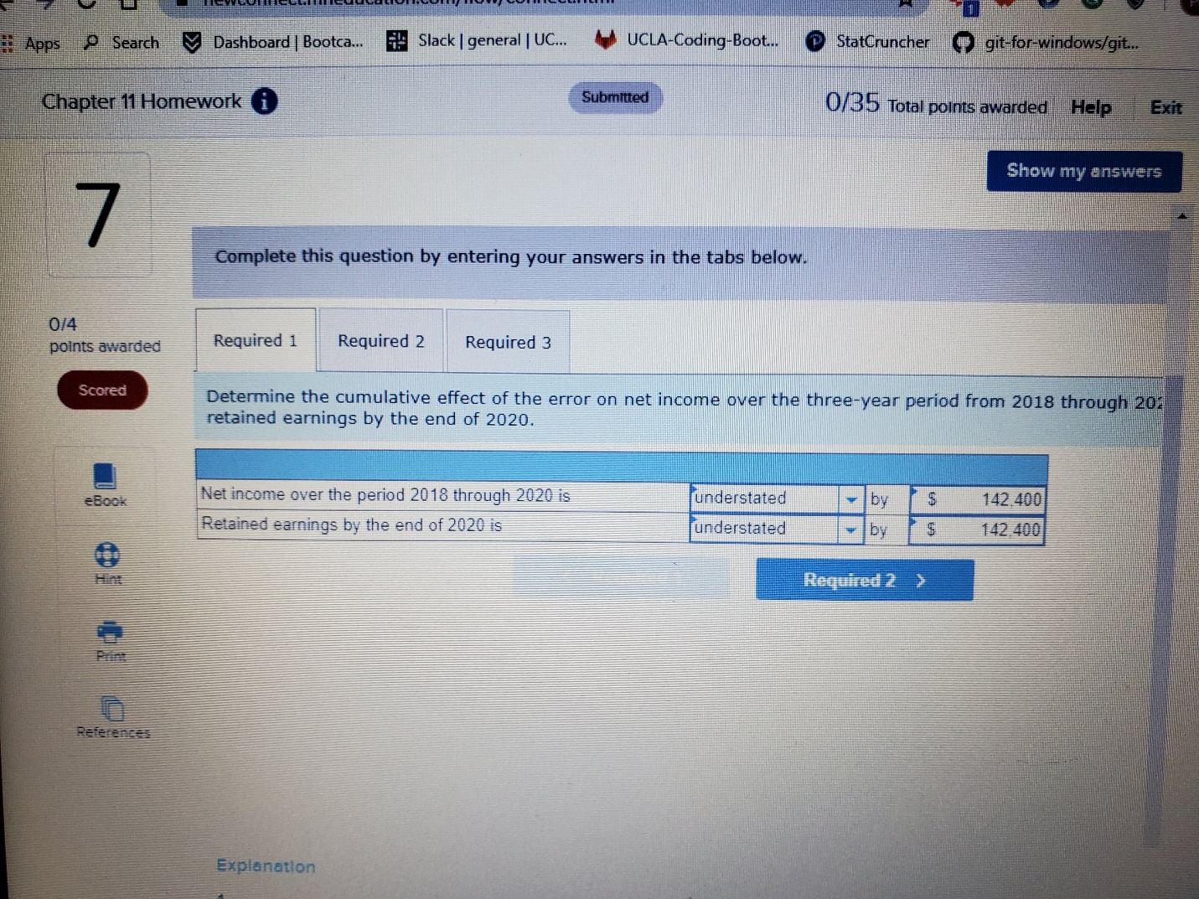

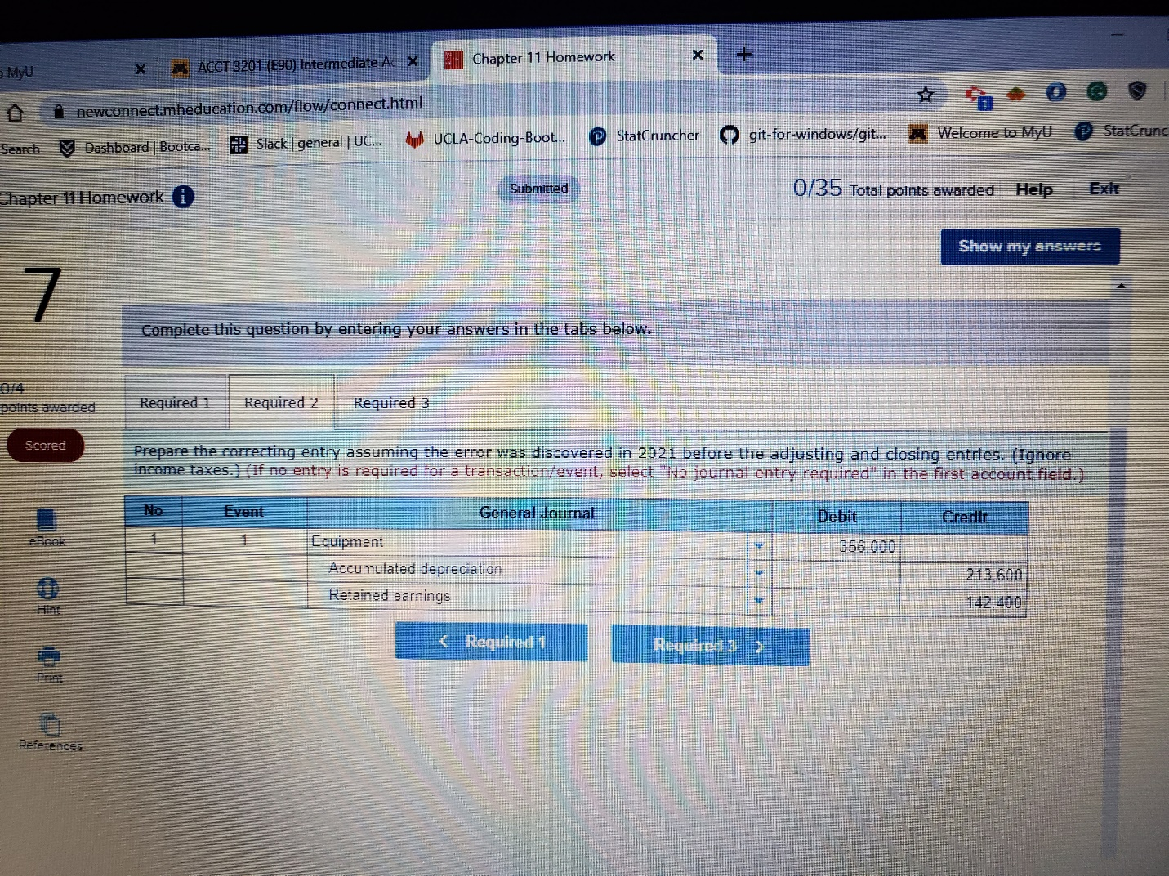

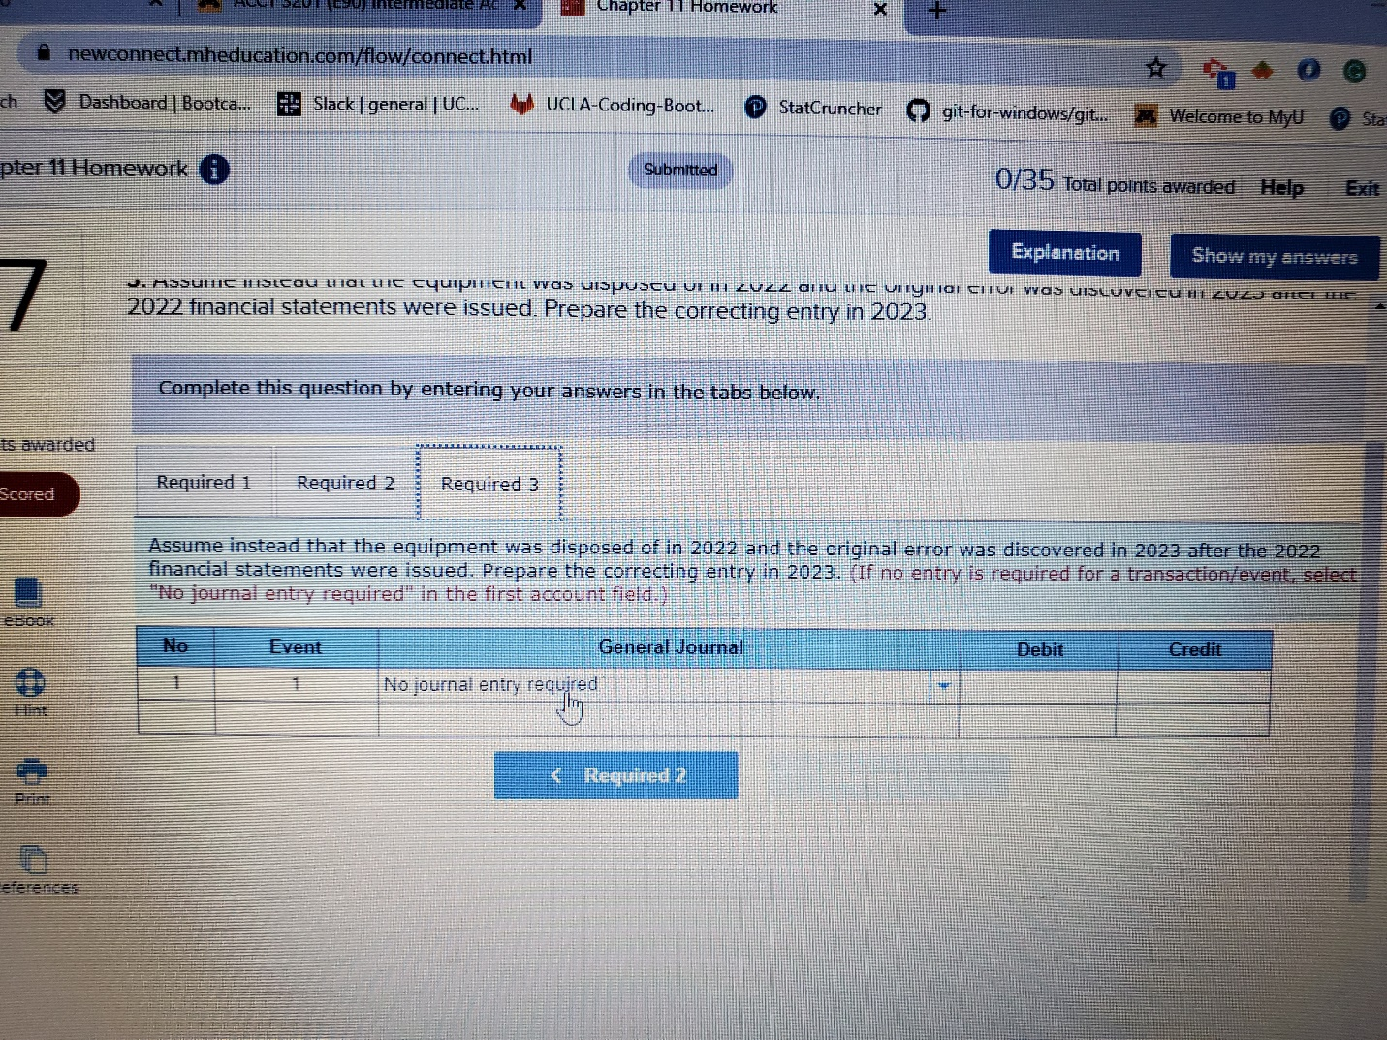

8. At the beginning of 2019, Metatec Inc. acquired Ellison Technology Corporation for $640 million. In addition to cash, receivables, and inventory, the following assets and their fair values were also acquired:

|  |  |  |  |
| --- | --- | --- | --- |
|  |  |  |  |
| Plant and equipment (depreciable assets) | $ | 154 | million |
| Patent |  | 44 | million |
| Goodwill |  | 110 | million |
|  | | | |

The plant and equipment are depreciated over a 10-year useful life on a straight-line basis. There is no estimated residual value. The patent is estimated to have a 5-year useful life, no residual value, and is amortized using the straight-line method.  
  
At the end of 2021, a change in business climate indicated to management that the assets of Ellison might be impaired. The following amounts have been determined:

|  |  |  |  |
| --- | --- | --- | --- |
|  |  |  |  |
| Plant and equipment: |  |  |  |
| Undiscounted sum of future cash flows | $ | 84 | million |
| Fair value |  | 64 | million |
| Patent: |  |  |  |
| Undiscounted sum of future cash flows | $ | 20 | million |
| Fair value |  | 13 | million |
| Goodwill: |  |  |  |
| Fair value of Ellison Technology Corporation | $ | 494 | million |
| Fair value of Ellison's net assets (excluding goodwill) |  | 430 | million |
| Book value of Ellison's net assets (including goodwill) |  | 510 | million* |
|  | | | |

*After first recording any impairment losses on plant and equipment and the patent.

**Required:**

**1.**Compute the book value of the plant and equipment and patent at the end of 2021.  
**4.**Determine the amount of any impairment loss to be recorded, if any, for the three assets.  
 

**Explanation**

**1.**  
Plant and equipment:  
Depreciation to date:  
$154 million ÷ 10 years = $15 million per year × 3 years = $46 million  
   
Book value: $154 million – $46 million = $108 million  
  
Patent:  
Amortization to date:  
$44 million ÷ 5 years = $9 million per year × 3 years = $26 million  
   
Book value: $44 million – $26 million = $18 million  
  
**4.**  
Plant and equipment:  
Recoverability test:  
An impairment loss is indicated because the $84 million undiscounted sum of future cash flows is less than the $108 million book value of the assets.  
   
Measurement:  
The amount of the impairment loss to be reported is calculated using the fair value rather than the undiscounted future cash flows:

|  |  |  |  |  |
| --- | --- | --- | --- | --- |
|  |  |  |  |  |
| Fair value | $ | 64 |  | million |
| Book value |  | (108 | ) | million |
| Impairment loss | $ | (44 | ) | million |
|  | | | | |

Patent:  
Recoverability test:  
There is no impairment loss because the undiscounted sum of future cash flows, $20 million, exceeds the book value of $18 million.  
   
Goodwill:  
Measurement of impairment loss:

|  |  |  |  |  |
| --- | --- | --- | --- | --- |
|  |  |  |  |  |
| Fair value of Ellison Technology's net assets | $ | 494 |  | million |
| Book value of Ellison Technology's net assets (including goodwill) |  | 510 |  | million |
| Implied loss | $ | (16 | ) | million |
|  | | | | |

